**Calorimetry Data Analysis** – Running the R Program “**Calorimetry Analysis.R**”

1. To use the **Calorimetry Analysis** R program, you must preprocess your data file.

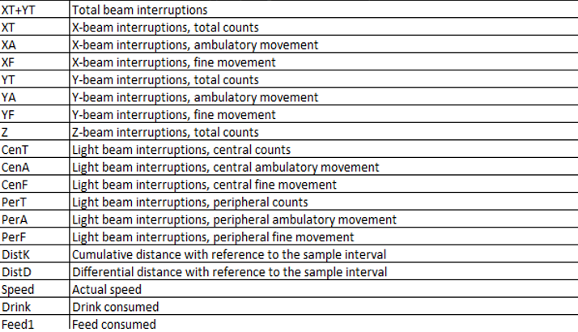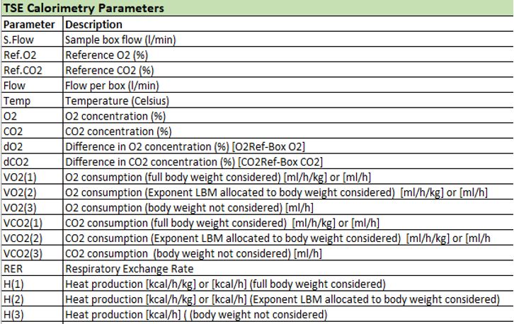The data can be viewed and preprocessed as an excel file. The TSEsystems Phenomaster reports the following measurements every 9 minutes for as long as the system is running.

1. The first step is to make sure there are no anomalies in the reported data or unusual behaviors in the mice. To do this, make sure flow rate and temperature are consistent throughout the experiment and between cages. Next, put the data from each mouse into separate excel files. Plot H3, RER, and XT as a function of time for each mouse to ensure normal behavior. You should see higher activity during the night hours. DLAM facilities have lights on from 7:00am to 7:00pm.
2. Mice will show unusually high activity as they acclimate to the new environment. To control for this disregard the first daytime period (approximately 8 hours). If activity appears abnormally high for longer than 8 hours in the XT vs time graph, you may have to disregard the entire first day and night period. You can also disregard the last partial day period, as it will not be a full 12 hours.
3. For determining metabolic phenotype we are only interested in Time, XT, RER, H3, VO2(3), and VCO2(3). For file preprocessing, remove all other columns from each individual mouse file.
4. H3 represents Energy Expenditure in kcal/hour. Create another column titled EE cal/min and covert the data from kilocalories per hour to calories per minute. Verify that the data in this column matches energy expenditure calculated by the Weir equation.

Metabolic rate (cal/min) = 3.94 VO2 + 1.11 VCO2

1. Make two new columns to calculate glucose oxidation and lipid oxidation, titled Gox and Lox, respectively.

Gox = (4.55*VO2)-(3.21*VCO2)

Lox= (1.67*VO2)-(1.67*VCO2)

1. Next, the data must be normalized to account for differences in body size and composition between mice. When comparing obese and lean mice, normalize data by kilograms of lean body mass to account for the metabolic differences between fat and lean tissues. Create new columns for normalized EE, VO2, VCO2, Gox, and Lox and divide by lean body mass determined by EchoMRI.
2. Make sure your final data file is formatted like this which the same headers as well:

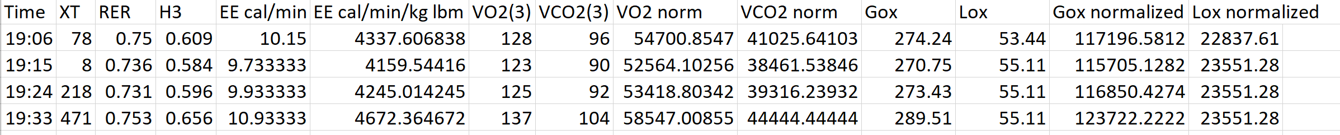

1. Next, make sure that each mouse is saved into a separate CSV file with the mouse ID and any other relevant information in the file name. For example, if you have mice with a specific genotype & diet make sure to include the mouse ID, genotype, and diet all in the file name.
2. Go into the program where the line begins with **setwd** and place your folder directory that contains ONLY your input files for the program.
3. Next go to the variable **all_params** and make sure that the first 3 column names listed in the setNames function are the correct column names you wish to include for each mouse (mouse identifiers) – all the calculation column names should remain the same.
4. Go under the comment “**#extracting mouse identifiers from file name (mouse ID, genotype, diet)**”. For your mouse identifiers alter the start & stop integers to reflect the location of the characters that contain your mouse’s info in the file name. For example, if your mouse ID is between the 7th and 9th letter in the file name, then place 7 and 9 as your start and stop characters respectively.
5. Scroll down to the very last line in the code and change your output file name (in the **write.csv** function) to the file name of interest.